**Attach your pre-lab answers to your report**

1. **Antenna, Local Oscillator, Mixer:**

* Sketch the signal LO at R33 and determine the frequency of the local oscillator.
* What is the IF frequency given fIF = flo - fradio station ?

1. **Signal at IF amplifier:**

* Measure the frequency of the IF signal:
* Ask for help from instructor to show that the detected audio signal follows the negative envelope of the IF. Sketch the two signals. Can you see any distortion (slope overload) caused by the envelope detector time constant? Describe it.
* Sketch or plot the spectrum of the signal at IF, TP3 and identify the carrier and the sidebands. Estimate the bandwidth of the signal.

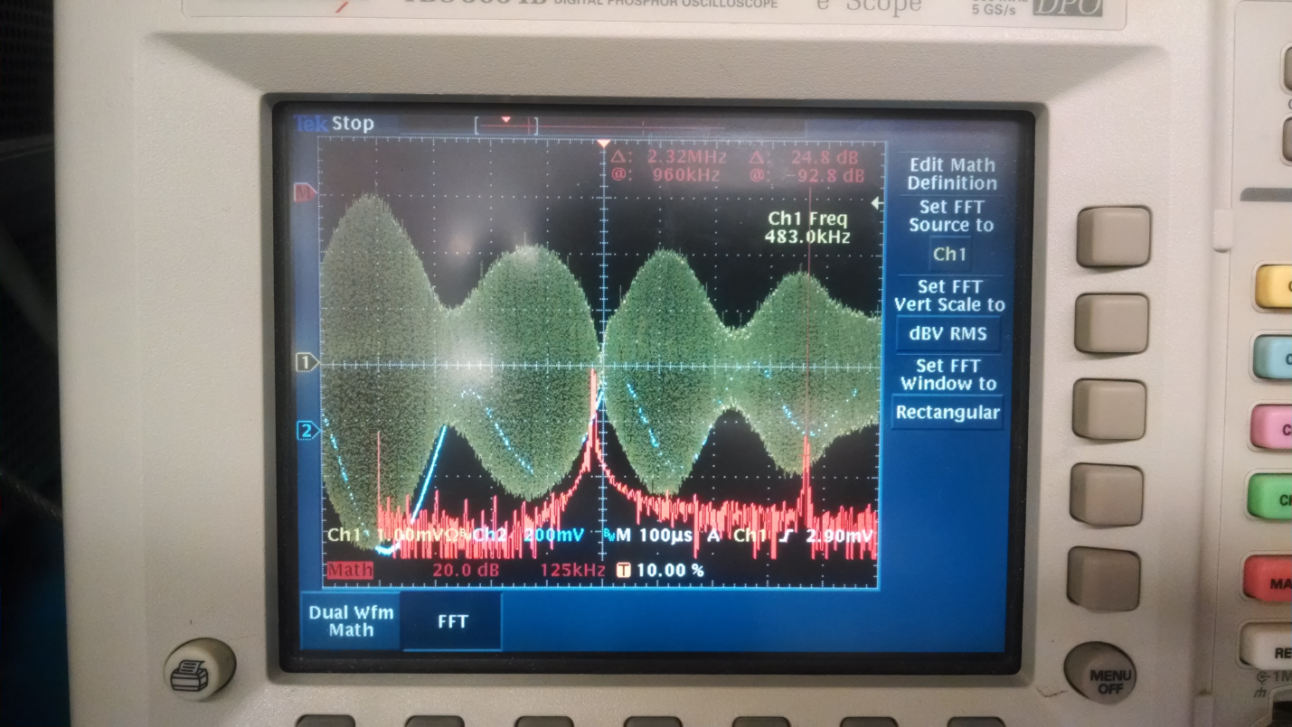

**The spectrum of the signal is from DC to 960 kHz, so the bandwidth is 960 kHz.**

1. **AGC-automatic gain control:**

* Re-tune the radio. Note how the dc level at TP5 varies as the input signal level changes. Does the voltage at TP5 increase, or decrease when the input signal strength increases?

**DC voltage decreases as signal strength increases.**

* Re-position the radio while watching the voltage at TP5. Is the ferrite coil AM antenna directional?

**The AM antenna is directional.**

1. **Audio Spectrum:**

* Can you observe discrete frequencies being present? Can you observe harmonically related frequencies in the spectrum?
* Observe the audio spectrums of signals at 1090, 1230, and 1450 kHz and give an estimate of the highest frequency that is being allowed in m(t) by each station.
* Are any of the stations exceeding the 5 kHz FCC bandwidth limit on m(t)?

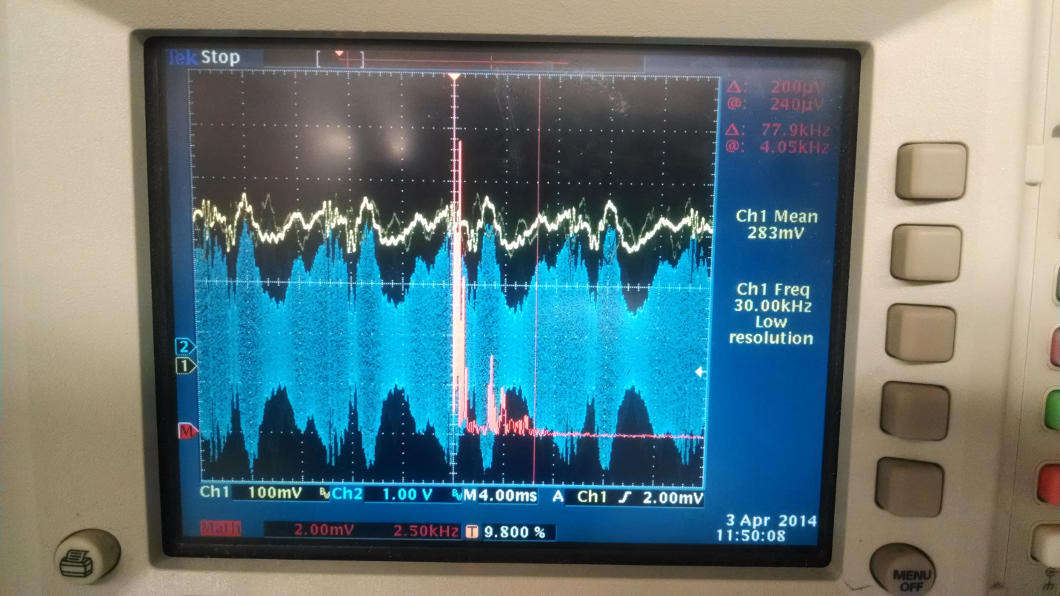

**The highest frequency in m(t) appears to be 5 kHz.**

1. **Generator input signal**

* Record the amplitude of the tone as you vary the modulating frequency, fm , from 100 Hz to 1 kHz in 100 Hz steps and from 1 Khz to 10 Khz in 1 Khz steps.
* Make a plot of H(f) vs fm . How well does this look like a perfect lowpass pass filter with fcut-off = 5 kHz?
* Is the image frequency at 900 kHz plus twice the IF frequency as found in (1)? Actual image frequency:

**The theoretical image should be at 1810 kHz, but in reality is at 1848 kHz.**